**Prees Walks**

**WALK 1 – Prees, Edstaston and Quina Brook**

**A clockwise 7 mile circular rural route including Prees Station and Edstaston Church**

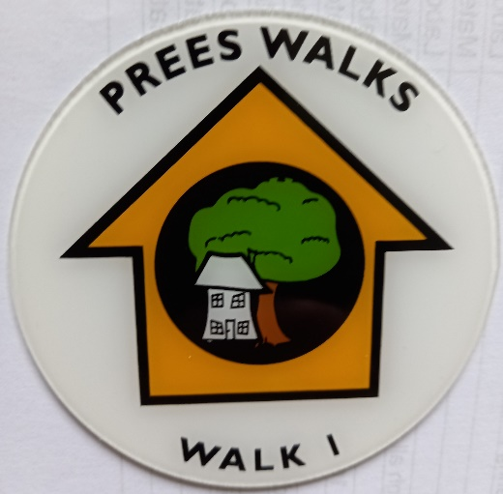

**Route notes**

1. The walk starts from Prees Cricket and Recreation Club car park

*NB. An alternative start is Prees Railway Station. Go to point 20.*

1. Walk down Brades Road away from the village of Prees. Pass the bungalow called Camsley and turn right through a kissing gate.
2. Cross the field to a gate and straight ahead to another gate. Turn left along the edge of the field and then right when you get to a farm track (there’s a farm to your left here). Walk along the track and just before a cluster of pine trees walk to the left. Go through the footpath gate in the gateway and head along the fence line towards a kissing gate on the far side of the field.
3. Go through the gate – carefully note the angle of the waymark direction indicator and head towards a power pole in the middle of the field – slightly left of a bungalow in the distance. There may be crops in this field but walk confidently in single file through them.
4. When you reach a kissing gate in the hedge on the far side of the field, go through it, turn right and walk along the road for 200 yards.
5. When you reach the driveway for Upper Lacon Farm turn left and walk up the driveway towards the farm. Before you reach the farm turn right through a kissing gate and follow the field headland – firstly straight ahead and then left when you reach the corner of the field.
6. Continue to the end of the field, bear left and then go through a metal footpath gate on your right, and turn right on the green lane.
7. Walk along the green lane and continue bearing slightly to the right when the green lane becomes a track.
8. Look out for the railway over to the left. On a power pole in the right hand hedge line look out for a waymarker disc that points on the line of the public footpath – take a diagonal line across the field to a stile adjoining the railway.
9. When you reach the railway you cross the stile, then cross the railway, and then cross another stile. BE VERY CAREFUL when crossing the railway.
10. Once you have crossed the stile on the far side of the railway walk straight across to the far side of the field ahead of you towards the largest oak tree on the far side of the field. Here you will find the path bears a little to the left and then over a wet ditch, and then on towards a farm gate. Climb over the farm gate and head across the field to a stile at the far end.
11. At the far end of the field cross the stile and continue straight on to a kissing gate in the far hedge which leads down onto the main B road from Whitchurch to Wem. Be careful of fast traffic as you cross the road and bear slightly to the right to where the footpath continues on the other side.
12. Follow the right hand field edge. Keep the rough young woodland on your right hand. When you reach a meadow on the left bear slightly right so the meadow fence is immediately on your left had side. Continue until you reach a long stile which takes you over a fence into a mown area adjoining Edstaston Church graveyard.
13. Walk through the double gates into the graveyard and then bear right down to a gate out onto the lane where you turn right. Walk along the lane past the wharf (you are crossing the line of the old Prees Branch Canal) and walk past village hall. When the road takes a sharp left hand turn, walk to the right and then in a fenced path to the right of a driveway up to a house.
14. When you have passed the house, you cross a stile in the fence to the rear of the property and cross a meadow to the next stile. This stile is tricky to cross – there is a very solid old wrought iron fence next to it – it is easiest to cross that. Go slightly to the left on a diagonal to cross another stile and walk straight on keeping the hedgerow on your left.
15. Continue straight. You will go through a farm gate and then the hedgerow will be on your right. Cross the stile at the end and turn right.
16. Continue through the farm gate to the far left hand corner where there is a stile. Cross the stile and a paddock – there is a building in front of you. Aim for the right hand side of the paddock where there is a stile in the hedge (the building will now be on your left). Cross the stile and turn left. Follow the path past a five bar gate keeping the hedge and trees on your left. Go down the slope and you will find, tucked away in the far left hand corner of the field, a stile leading into a tree covered narrow “tunnel” pathway.
17. Cross a couple of stiles and you arrive at the B road again. Cross the road, turn right and then walk to the road junction where you turn left.
18. Walk along the road for half a mile. A little way past Bridge Farm on your right, take the Bridleway track on the left. Follow the track until there is an open gateway on your left where the track continues to the left – do not follow the track. At this point bear right towards a farm gate on the far side of the field. Go through this farm gate and then another gate – the second gate is next to the railway. Keep walking with the railway on your right. The track briefly veers left away from the railway (around some trees) before coming back alongside it. Eventually you’ll arrive at Prees Station.
19. *Alternative start point. If arriving by train from Shrewsbury or parking at Prees Station, cross the level crossing towards Prees village*.

If continuing on the main route cross the level crossing towards Prees village.

1. Walk for 300 yards along the road until you reach a right hand bend where a farm track turns off to the left. The fingerpost in the right hand verge points the way.
2. Follow the waymarkers around to the right keeping the farm and barns all on your left side. Follow the path straight ahead. There are often electric fences here with clip handles. Take care and firmly grasp the clip handle to unclip the electric fence and walk through. Re-clip the electric fence after you have passed through.
3. Head straight ahead towards the white house. Go through 2 kissing gates and keep walking straight. You walk past the front of the house (Lily Hall) and onwards down their driveway.
4. When you reach the lane turn right. Follow the road to the end. At the T junction turn left walk past the children’s playground on your right and walk right into Brades Road.
5. Walk along Brades Road for 200 yards until you reach Prees Cricket and Recreation Club car park. You have completed your walk.